Graduation is right around the corner
Veronika Suyupova, Student journalist, SPCHS
May 5, 2016
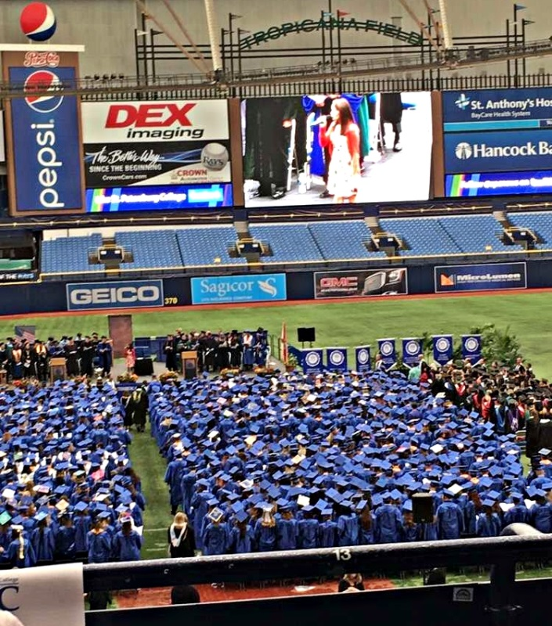
As the school year approaches its end, Saint Petersburg Collegiate High School (SPCHS) students are thrilled about summer. However, seniors have one last activity left: graduation. With prom, Grad Bash and exams out of the way, seniors are preparing for their college graduation ceremony, held at Tropicana Field, Saturday, May 7 at 9 a.m.
The class of 2016 agrees that the week leading up to graduation is a breeze. With exams done, seniors are treated to a luncheon supported by the Parent Teacher Student Association and the school. The end of the year activities, such as prom, united all of the students. The Award Ceremony pointed out the true potential in every senior, Grad Bash allowed seniors to hang out with their friends outside of school, and graduation will be the big day where they will be transitioning from high school students to adults. Evan Hauser and Angelica Morse, senior Student Government Association (SGA) members, said, “The Collegiate program has helped us by providing free money, prepare for college, and give helpful experience,” which they can use in the years of education ahead of them.
St. Petersburg College (SPC) graduation on Saturday, May 7th at Tropicana Field
Photographed by Veronika Suyupova
Seniors who have met all of the degree requirements will be receiving not only a high school diploma, but a Saint Petersburg College (SPC) diploma as well. They will be leaving this school with memories that will last a life time, but most importantly, with free money that will reduce the price of college in the future. An array of scholarships is provided, such as Bright Futures, Take Stock in Children, and many college awards. Constance Boyle, SPCHS counselor, said, “It’s important to join clubs, run for SGA, participate in game and movie night, attend Prom and get involved by volunteering,” mainly because colleges love seeing on an application that students are being active and getting involved in multiple school and community activities.
The future depends on the new generation of doctors, engineers, lawyers, teachers, scientists and . A huge thanks goes out to SPC for being the number one contributor and allowing a wonderful opportunity for excelling students to get ahead in a degree and career of their choice.

