Let's taco about Chipotle
Veronika Suyupova, SPCHS student journalist, May 24, 2016
Fast food chain restaurants are famous for their quick, efficient and mainly greasy food. But why not make it healthy and non GMO? Chipotle Mexican Grill is the new trend of "eat quick and organic."
Chipotle is the rising business on the fast food market. With their new program, “Food with Integrity”, people are able to enjoy food fresh, where vegetables have been grown in rich soil and the pigs have been raised free-roaming outside. Although food takes time to prepare, due to the use of high-quality raw ingredients, the service remains fast. The long lines vanish in matter of minutes, and the burrito bowls leave customers happy.
The restaurant doesn’t look like all the regular diners. Instead, the design seems more industrialized; concrete floors, exposed roof pipes, and the steel surrounding walls and tables make this place one of a kind. Friendly, casual people and employees give off positive vibes. The atmosphere is filled with the delicious aroma of spicy Mexican food and freshly made guacamole. The inside becomes louder as more hungry people enter the building; however, the restaurant supports the idea of outside sitting arrangements with umbrellas to hide under from the Florida’s blazing sunshine.
The Chipotle Mexican Grill on 1418 66th St. N. serves the same food as all the other Chipotle restaurants. The options are limited to a rice bowl, burrito, crispy and soft tacos, and salad. The kids menu includes a cheese quesadilla or “build your own” option. The food is very universal and fits many different personality types from vegetarian to meat lovers.
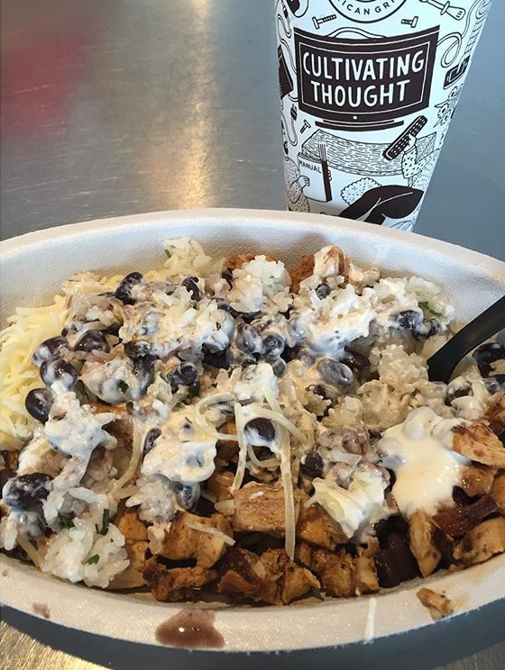
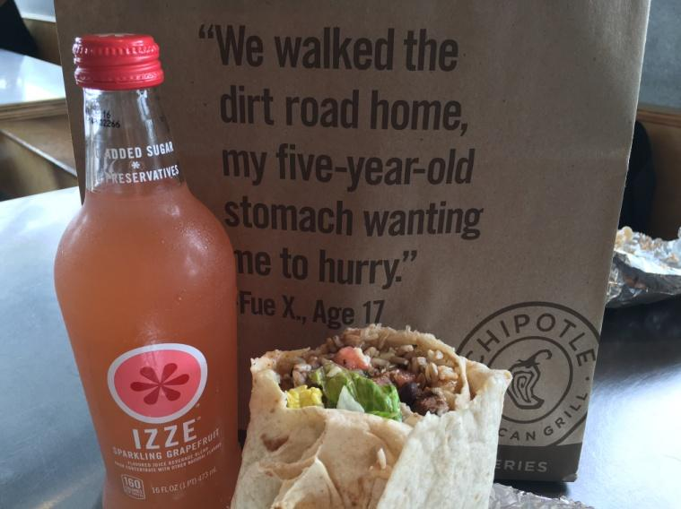
At the arrival, it was very difficult to find parking. Going during lunch hour break, the place gets busy and very crowed. No reservations are needed; people build their own desired dishes on the spot. I decided to order a steak bowl ($7.50), a chicken burrito ($6.50), steak tacos ($6.50) and a vegetarian salad bowl ($6.50). Although guacamole is extra (+$1.95), it does serve as the cherry on top. The average price of the meal turned out to be $29. The steak bowl is my personal favorite. The richness of ingredients blooms with every bite, leaving taste buds tingling with the flavorful taste of Chipotle spices. The perfectly prepared brown rice, mixed with pinto beans and grilled fajita veggies is only the beginning of an emotional roller coaster of savory Mexican food. Mixed together with chipotle seasoning, the grilled steak leaves a burning sensation in the mouth from the spice of chili pepper. On top, I added sour cream and cheese. The chicken burrito is practically the same thing as the bowl, but it’s wrapped in a soft, warm tortilla for easy handling and consumption. The soft grilled chicken melts in the mouth, leaving a warm feeling of deliciousness at the depth of the heart. Guacamole is never too extra; it only brings out the true Mexican culture. The steak tacos surprised me because of their miniature size. The serving consists of three tacos among the selection of soft and crispy taco shell. The last dish I tried was the salad. The salad is prepared similarly to the bowl, but instead of rice, it’s replaced with lettuce. Fine cut lettuce with grilled veggies, green bell pepper and onion, has a unique crunch to it, proving the freshness of ingredients.
Steak Burrito Bowl mixed with sour cream and cheese
By Veronika Suyupova
Daily Chipotle take-out: Burrito and an Izze grapefruit drink
By Veronika Suyupova
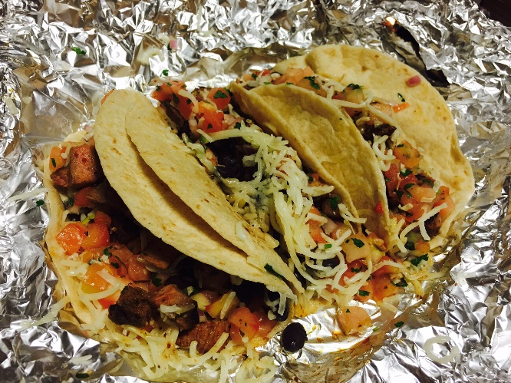
Chipotle Mexican Grill verifies its mission statement of “Food with Integrity.” The quality of ingredients stays fresh, and only healthy food options are presented to the table. The great, friendly service attracts more people to the business and lets them go with happy attitude and filled belly. Being a true supporter of Chipotle, I would definitely come back again to experience the delicious foods.
Steak, soft shell Tacos with mild salsa
By Veronika Suyupova

